Real World Challenge - API Mashathon, with HP IDOL OnDemand

Deployment Guide

Revision History
Author | Revision Number | Date
TCCODER | 1.0 | 27.02.2015
Real World Challenge - API Mashathon, with HP IDOL OnDemand 1
1.Organization of Submission 3
2.Application Setup 3
3.Deployment Instructions 4
4.Starting 4
5. Testing 4
6. Resource Contact List 6

Organization of Submission
The submission structure is as follows:
Folder | Description
docs/ | Contains documentation.
src/ | Contains the application source code.
uploads/ | Folder where file uploads will be temporary stored.
.editorconfig | See here for details.
.jshintrc | JSHint configuration file.
env_sample | Example .env file.
package.json | NPM configuration file.
Procfile | Heroku's process configuration.
SUBMISSION.txt | Contains links and hints about this submission.
Additionally there is a video of the solution in action which is not included in the submission for file size reasons but is available here:
Link
Also there is a blog post outlining use case and how the various API's are used in the application here:
Link

Application Setup
The application requires:
- Node.js
- NPM
You need to have those installed to run the application locally. For how to install them see the corresponding guides.
To be able to work on different operating systems and Heroku the application uses environment variables for configuration. They are read from the .env file. So set them as needed before starting the app. Depending on your OS look at the corresponding documentation of how to set environment variables. But the best way is to provide a .env file in the project folder. Look at env_sample for example .env file.
The table bellow describes the name/value for those variables:

Name of variable | Default value
IDOL_API_KEY | The IDOL Ondemand API key to use.
MAILJET_API_KEY | Mailjet API key to use.
MAILJET_SECRET_KEY | Mailjet secret key to use.
APP_USERS_IDOL_STORE | Optional. The name of the user store containing application users. Defaults to `emailondemand` when not set.
APP_EMAILS_IDOL_INDEX | Optional. The name of the text index where emails should be indexed. Defaults to `emailondemand` when not set.
NODE_ENV | Optional. Variable to diferentiate between development and production modes. Defaults to `debug` when not set.

Deployment Instructions
This application can be deployed locally and/or to Heroku.

- Local deployment
- To deploy locally copy the submission .zip to some folder and extract it. This will provide the source code in the folder.
- Run [sudo] npm install to install all node modules needed by the application.
- Provide .env file in the project root. See env_sample for how to do it.

- Heroku
This submission is Heroku ready. Please, note that you need to include a .env file before pushing to Heroku or define the environment variables via the Heroku app web GUI. One of those should happen before you push the code! Otherwise it will fail to start. To deploy on Heroku follow the corresponding guide.

Starting
- Local
If you have the Heroku tool belt you will have foreman which you can use to start the service easily. To do so in the app folder type:

[sudo] foreman start -p 3333

If you like you can use NPM to start the service too:

[sudo] npm start

Starting with node directly is also possible:

[sudo] node ./src/server.js

- Heroku
You application will be started automatically for you by Heroku because it comes with the required Procfile which is placed in the root folder of the application.

5. Testing
Before you start testing please make sure that the needed user store and text index are created in your IDOL OnDemand account. To do so login to your IDOL account and then:

- Navigate to Add Store's try section and use it to create one user store according your likings. The name you set there is the value of APP_USERS_IDOL_STORE. It should look something like the screen bellow:
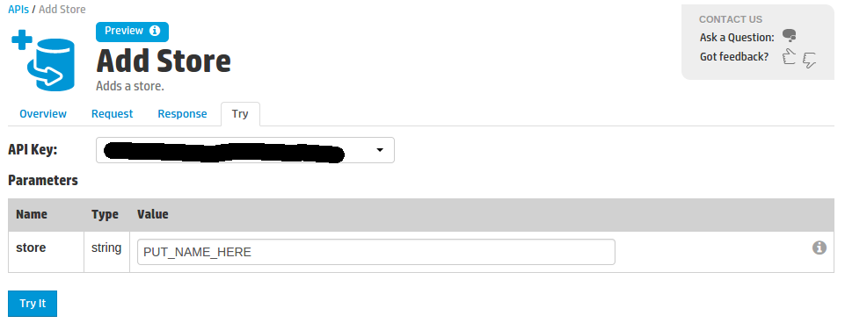
- Next, navigate to Create Text Index's try section and use it to create one text index according your likings. The name you set there is the value of APP_EMAILS_IDOL_INDEX. It should look something like the screen bellow:
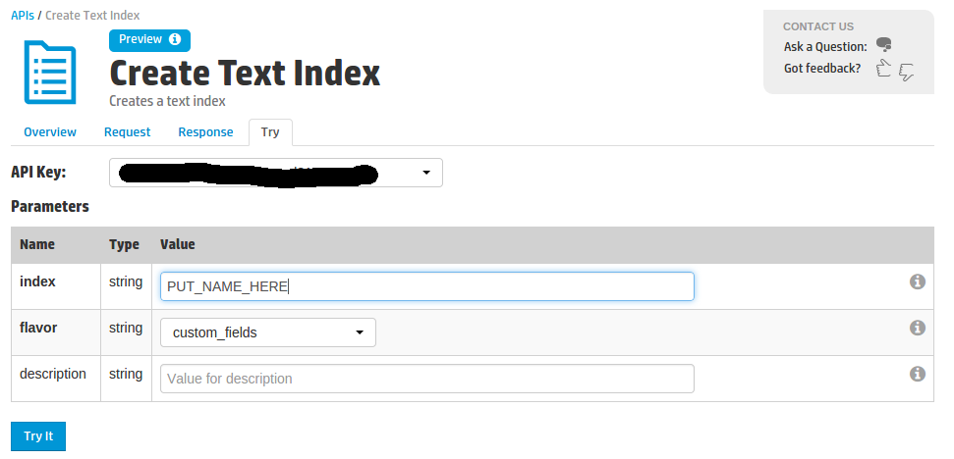
Now you are ready to test locally and/or via Heroku!

This submission provides demo service already running on Heroku for testing purpose and to demonstrate better the way it works. It is available here:

Link

To use login with:
user: email.ondemand.app@gmail.com
pass: test1234

To test locally make sure you have completed steps 2-4 and then navigate with your browser to:

http://localhost:<PORT>

PORT will be 3333 by default but if you have changed it, reflect the propriate value above!

6. Resource Contact List

Name | Resource Email
Kiri4a | kiri4a@gmail.com

